Tutorial on Heart Rate Variability (HRV):
signal capturing and analysis

Kais Siala
CES Lab, ENIS, Sfax, University of Sfax, Tunisia
s_kais@yahoo.com

What is Heart Rate Variability?

Heart rate variability (HRV) is the physiological phenomenon of variation in the time interval between heartbeats. It is measured by the variation in the beat-to-beat interval.
Other terms used include: "cycle length variability", "RR variability" (where R is a point corresponding to the peak of the QRS complex of the ECG wave; and RR is the interval between successive Rs), and "heart period variability".

Methods

Methods used to detect beats include: ECG, blood pressure, ballistocardiograms and the pulse wave signal derived from a photoplethysmograph (PPG). ECG is considered superior because it provides a clear waveform, which makes it easier to exclude heartbeats not originating in the sinoatrial node. The term "NN" is used in place of RR to emphasize the fact that the processed beats are "normal" beats.

A - Electrocardiography (ECG)

Electrocardiography (ECG or EKG) is the process of recording the electrical activity of the heart over a period of time using electrodes placed on the skin. These electrodes detect the tiny electrical changes on the skin that arise from the heart muscle's electrophysiologic pattern of depolarizing and repolarizing during each heartbeat. It is a very commonly performed cardiology test.
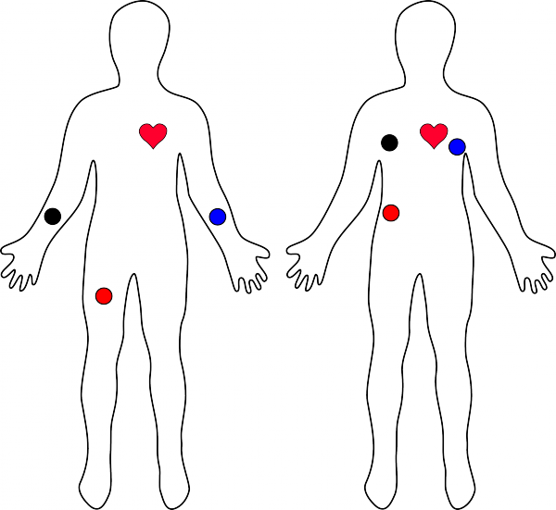

In general terms, lets look at what an ECG is representing and how we’re able to sense it. The ECG is separated into two basic Intervals, the PR Interval and the QT Interval, described below.

. 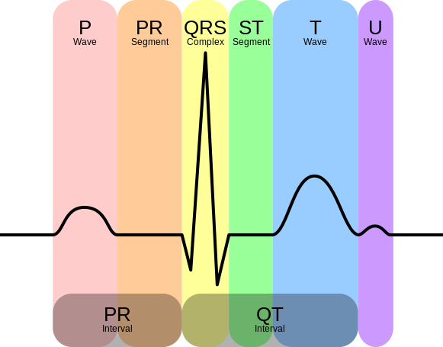

Connecting the Hardware

In this tutorial, we’ll connect the AD8232 Breakout to an Arduino microcontroller. We will build a simple cardiac monitor that will allow you to measure the electrical activity of the heart in real time!

Pin Connections

The AD8232 Heart Rate Monitor breaks out nine connections from the IC. We traditionally call these connections “pins” because they come from the pins on the IC, but they are actually holes that you can solder wires or header pins to.
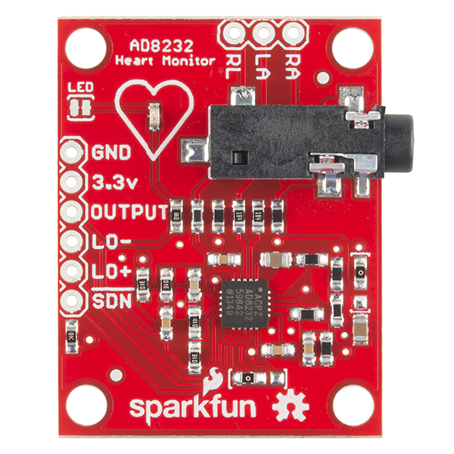
We’ll connect five of the nine pins on the board to your Arduino. The five pins you need are labeled GND, 3.3v, OUTPUT, LO-, and LO+.

Board  Label | Pin Function | Arduino Connection
GND | Ground | GND
3.3v | 3.3v Power Supply | 3.3v
OUTPUT | Output Signal | A0
LO- | Leads-off Detect - | 11
LO+ | Leads-off Detect + | 10
SDN | Shutdown | Not used

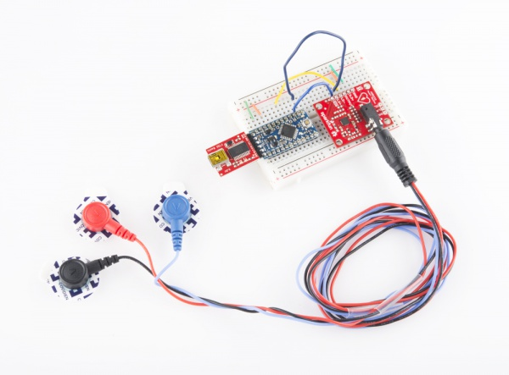

Uploading the Sketch and Connecting with Processing

By this point, you should have the hardware connected and ready.
The sketch can be found on github. You can cut and paste the code straight from github or clone the repository and open the file.

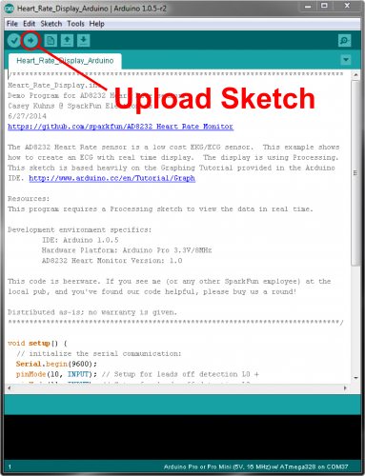

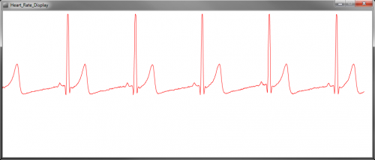

B- photoplethysmogram (PPG)

A photoplethysmogram (PPG) is an optically obtained plethysmogram, a volumetric measurement of an organ. A PPG is often obtained by using a pulse oximeter which illuminates the skin and measures changes in light absorption. A conventional pulse oximeter monitors the perfusion of blood to the dermis and subcutaneous tissue of the skin.

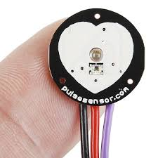
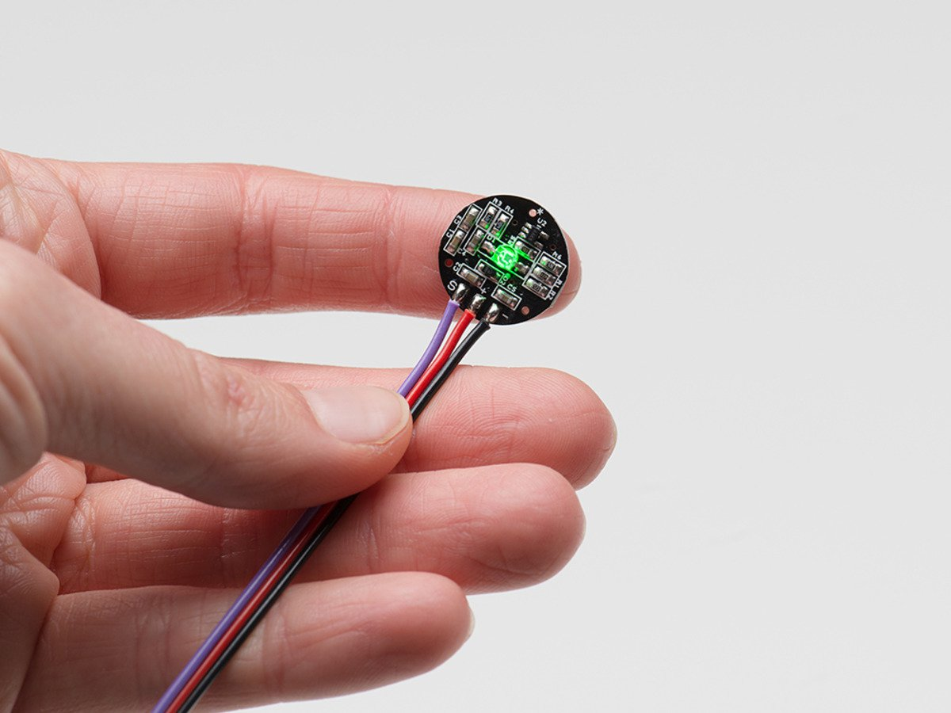
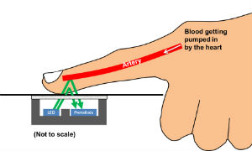

HRV analysis

The most widely used methods can be grouped under time-domain and frequency-domain. Other methods have been proposed, such as non-linear methods.

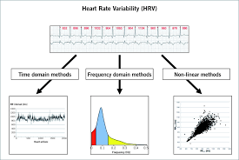

A - Time-domain methods

These are based on the beat-to-beat or NN intervals, which are analyzed to give variables such as:

- SDNN, the standard deviation of NN intervals. Often calculated over a 24-hour period.

- SDANN, the standard deviation of the average NN intervals calculated over short periods, usually 5 minutes. SDANN is therefore a measure of changes in heart rate due to cycles longer than 5 minutes. SDNN reflects all the cyclic components responsible for variability in the period of recording, therefore it represents total variability.

- RMSSD ("root mean square of successive differences"), the square root of the mean of the squares of the successive differences between adjacent NNs.

- SDSD ("standard deviation of successive differences"), the standard deviation of the successive differences between adjacent NNs.

- NN50, the number of pairs of successive NNs that differ by more than 50 ms.

- pNN50, the proportion of NN50 divided by total number of NNs.

- NN20, the number of pairs of successive NNs that differ by more than 20 ms.

- pNN20, the proportion of NN20 divided by total number of NNs.

B - Geometric methods
The series of NN intervals also can be converted into a geometric pattern such as: Geometric Measures HRV triangular index: integral of density distribution / maximum of density distribution maximum HRV triangular index = Number of all NN intervals / maximum number.Dependent on the length of the bin -> quote the bin size+ relative insensitive to the analytic quality of the series of NN intervals -need of reasonable number of NN intervals to generate the geometric pattern (in practice 20 min to 24 h)-not appropriate to assess short-term changes in HRV

- the sample density distribution of NN interval durations;

- sample density distribution of differences between adjacent NN intervals;

- a scatterplot of each NN (or RR) interval with the immediately preceding NN (or RR) interval— also called a "Lorenz plot"; and so forth. A simple formula is then used that judges the variability on the basis of the geometric and/or graphics properties of the resulting pattern.

C - Frequency-domain methods
Frequency domain methods assign bands of frequency and then count the number of NN intervals that match each band. The bands are typically high frequency (HF) from 0.15 to 0.4 Hz, low frequency (LF) from 0.04 to 0.15 Hz, and the very low frequency (VLF) from 0.0033 to 0.04 Hz.

Several methods of analysis are available. Power spectral density (PSD), using parametric or nonparametric methods, provides basic information on the power distribution across frequencies. One of the most commonly used PSD methods is the discrete Fourier transform. Methods for the calculation of PSD may be generally classified as nonparametric and parametric. In most instances, both methods provide comparable results. The advantages of the nonparametric methods are (1) the simplicity of the algorithm used (fast Fourier transform [FFT] in most of the cases) and (2) the high processing speed. The advantages of parametric methods are (1) smoother spectral components that can be distinguished independent of preselected frequency bands, (2) easy postprocessing of the spectrum with an automatic calculation of low- and high-frequency power components with an easy identification of the central frequency of each component, and (3) an accurate estimation of PSD even on a small number of samples on which the signal is supposed to maintain stationarity. The basic disadvantage of parametric methods is the need of verification of the suitability of the chosen model and of its complexity (that is, the order of the model).

A newly used HRV index, which depends on the wavelet entropy measures, is an alternative choice. The wavelet entropy measures are calculated using a three-step procedure defined in the literature. First, the wavelet packet algorithm is implemented using the Daubechies 4 (DB4) function as the mother wavelet with a scale of 7. Once the wavelet coefficients are obtained, the energy for each coefficient are calculated as described in the literature. After calculating the normalized values of wavelet energies, which represent the relative wavelet energy (or the probability distribution), the wavelet entropies are obtained using the definition of entropy given by Shannon.

D- Non-linear methods

Given the complexity of the mechanisms regulating heart rate, it is reasonable to assume that applying HRV analysis based on methods of non-linear dynamics will yield valuable information. Although chaotic behavior has been assumed, more rigorous testing has shown that heart rate variability cannot be described as a low dimensional chaotic process However, application of chaotic globals to HRV has been shown to predict diabetes status. The most commonly used non-linear method of analysing heart rate variability is the Poincaré plot. Each data point represents a pair of successive beats, the x-axis is the current RR interval, while the y-axis is the previous RR interval. HRV is quantified by fitting mathematically defined geometric shapes to the data. Other methods used are the correlation dimension, nonlinear predictability, pointwise correlation dimension, detrended fluctuation analysis, approximate entropy, sample entropy, multiscale entropy analysis, sample asymmetry and memory length (based on inverse statistical analysis). It is also possible to represent long range correlations geometrically.

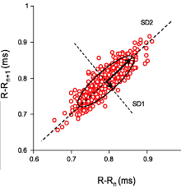

Marcus Vollmer library

The Matlab® user interface gives you an easy-to-use operating surface which is divided in five parts.

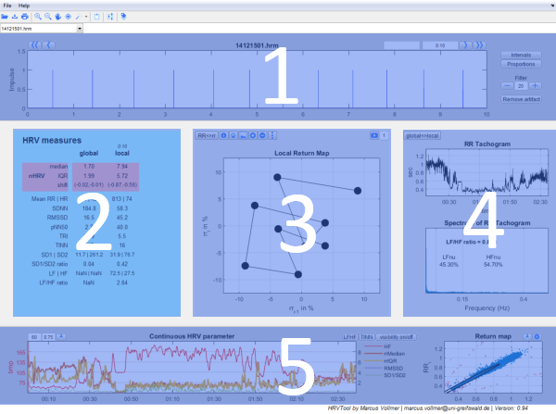
In the upper panel of the program you have the graphics of RR intervals with options for labeling, filtering and display.
The central panel has three sections:
On the left you have all common parameters for HRV analysis.
In the middle you have the graphics of successive intervals.
On the right your data is represented in the Tachogram and Spectrogram.

In the lower panel you see the chronological sequence of heart rates and local HRV parameters on the left. To its right there is the scatterplot of all RR intervals (predecessor vs. successor) - also known as Poincaré Plot. There you can easily detect and remove artifacts.

A - HRV measures

The results of the analyzed data splits into a rose and green shaped area. The highlighted rose shaped area contains parameters of the Heart Rate Variability (HRV) by using relative RR intervals/ proportions of RR intervals. All other measures are the common measurands of variability which are recommended in the guidelines of 1996 of the "Task Force of The European Society of Cardiology and The North American Society of Pacing and Electrophysiology". The global column shows the calculated measurands of the whole data set. The local column shows the calculated measurands of the current time period. The period in seconds is shown in italics.

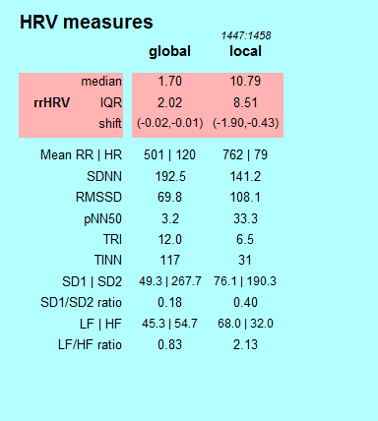

B - Tachogram und Spectrum

On the far right of the middle panel you will see the "RR-Tachogram" and the "Spectrum of RR-Tachogram".
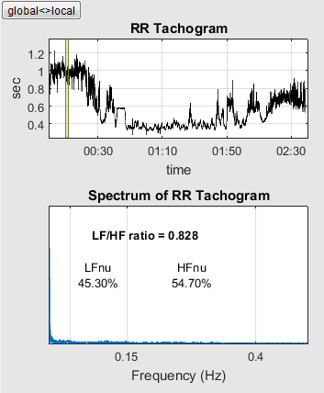
The RR-Tachogram represents the RR intervals in dependence to its time. The local view provides information about the current time period. The global view shows the complete time period.
In the Frequency spectrum the interpolated RR-Tachogram will be decomposed into sine waves of different frequencies. The spectrum maps the weights of those sine waves. It becomes clear to the user, which frequency components outweigh during the RR measurement.

References

- https://learn.sparkfun.com/tutorials/ad8232-heart-rate-monitor-hookup-guide.
- https://en.wikipedia.org/wiki/Heart_rate_variability
- https://github.com/MarcusVollmer/HRV
- http://marcusvollmer.github.io/HRV/manual_english.html

